**IE 6308 - Design of Experiments Project Report**

**Spring 2015**

**Billy Gray**

**Ashkan Aliabadi Farahani**

**Nilabh Ohol**

**Problem Description:**

In this project, we propose to test the mechanical properties of composite materials that have RFID tags embedded into the layers of the material. Previous research from Dumstorff, Paul, and Lang (2014) utilized a simulated analysis of what mechanical strengths occur in these materials but no one has published research in this area. Our interest in this research is to try and determine with physical testing that the inclusion of small scale electronics such as RFID does not significantly affect the mechanical properties of a part. The materials to be used in this experiment are a Kevlar reinforcement suspended in an epoxy matrix and glass reinforcement suspended in an epoxy matrix. The RFID tag is an Alien ALN-9640 Higgs 3 tag.

In this proposal four types of parts will be analyzed. The first part will be our control part that has no RFID tag embedded into the material. The second part will have the Alien tag embedded into the layers of the material. The third part will have the same Alien tag embedded but with the backing material cut away leaving only the antenna and IC. The fourth part will again be the same Alien tag but the tag will be abraded with a sand paper. There will be two types of reinforcements used in this research. One is a Kevlar while the other is glass. Kevlar has been selected because of its status as an advanced composite reinforcement and glass because it is an engineering composite and the most widely used type of composite reinforcement. The results will be obtained through testing compression strength. These tests are designed to measure the bonding of the matrix to the reinforcement as well as the compressive strength of the reinforcement.

**Experimental Units:** 5 samples of Kevlar reinforced polymer for each tag type (i.e. 20 samples of Kevlar reinforced type)

5 samples of glass reinforced polymer for each tag type (20 samples of glass reinforced type)

**Factor A:** Tag modification with levels

1 = no tag included (control)

2 = complete tag

3 = cut away tag

4 = abraded tag

**Factor B:** Reinforcement type with levels

K = Kevlar

G = Glass

**Treatments:** The treatments are the factor level combination. For this experiment, the set of treatments are, K1, K2, K3, K4, G1, G2, G3, and G4. Where, K and G are Kevlar and Glass reinforcements respectively and 1, 2, 3, 4 are Factor A (tag modification) levels.

**Response:**

Compression strength (in psi) obtained from the compression test

**Goal:** To determine at each tag level for each material type if the failure of the samples with embedded tags is significantly different than the controls.

**Design:** The total number of treatments is 4 * 2 = 8. We will perform 5 replications for each treatment for a total of 40 parts that need to be run. The 5 replications requirement is based on the test specifications. Each part will be numbered in order to maintain traceability of the part. The design that would be used for conducting the experiment would be a two-factor complete factorial experiment. Where, the two factors are type of tag modification and type of reinforcement. This experiment will be a balanced complete factorial experiment.

**Data collection:** Data will be collected off of the test unit. All measurements will be taken in pounds per square inch (psi). Parts will be manufactured with 4 tags in each part, one of each tag type. After the material has been cured, the test specimens will be cut from the parts and measured. The test specimens will be determined randomly so that there are 5 of each type of tag the test. The randomization will occur through the randomization function assigned to five cells in Excel that will be concatenated to build a five digit number. The numbers as assigned to the treatments will be sorted least to greatest in order to randomize the treatments. The randomized series of numbers is included on Appendix.

The compression data was performed by cutting test samples from the coupons previously built. Each Kevlar test specimen is approximately 0.5” x 0.18” x 1.5” and each glass test specimen is approximately 0.5” x 0.11” x 1.5”. The main difference in thickness is the fabric densities; the Kevlar is 6 ounces per yard versus the 5 ounces per square yard for the glass. For the compression test, all specimens were placed in a specimen holder to hold their orientation during the test. The rate of compression was set to 0.05”/minute and the test specimens were tested according to the randomization as presented on page 3 of the proposal. To keep some objectivity, students in the composite class ran the tests under Gray’s supervision. The students set up the test specimens, ran the test equipment, and collected and logged the loads and dimensions from the experiment in Excel. The Excel file was then manipulated to convert the load from the machine into strength by dividing the load observed in pounds by the average area of the part in square inches. The data presented to the team included the tag number (i.e. G1, G2, K1, K2, etc.) and the calculated strength in PSI.

**II. Preliminary Analysis of Model Assumption**

**Raw Data in Plots and Discussion**

Two plots that may help for the very first analysis are collected data on actual compression strength (psi) vs treatment combination (4 levels of tag * 2 levels of reinforcement =8 treatment combination) or vs any of two factors (tag or reinforcement), by keeping level of one factors constant while the level of the other factors change. The two plots are provided here.

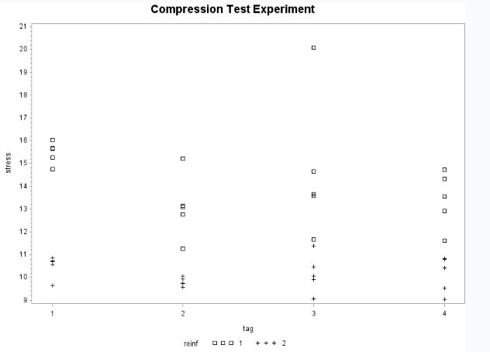

Figure 1: actual compression strength Vs. 4 levels of tag

Reinf 1 = Kevlar, Reinf 2=Glass

Tag1= no tag included (control), Tag2 = complete tag, Tag3 = cut away tag, Tag4 = abraded tag

Firstly, the vertical two point arrows may suggest that Kevlar reinforcement has higher compression strength than Glass reinforcement. Secondly, as we go from no tag (1) to abraded tag (4), compression strength seems to be slightly lower (red arrow). Moreover, we might notice in treatment combination of tag3 and Kevlar reinforcement, there might be an outlier shown by an orange circle. All of these comments from raw data need further test and analysis to be confirmed.

Also, by looking at boxplot, we can see the same comment above, adding that constant variance of the error term seems not to be the same.

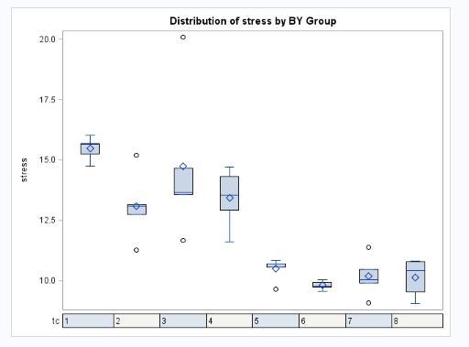

**Form of the Model**

As we stated earlier, the model is a balanced two factor complete factorial experiment in the following from:

Cell means Model (Fixed Effects):

Full Interaction Model: $Y_{ijt}{=μ_{ij}+ε_{ijt} μ}_{ij}= μ_{..}+τ_{ij}= μ_{..}+ α_{i}+ β_{j}+({αβ)}_{ij}$, $ε_{ijt}\sim N(0,σ^{2})$

$Y_{ijt}= t^{th} observed value of compression strength in psi at i^{th} level of tag and j^{th} level of reinforcement$

$µ_{..}$ = Overall mean of the the compression strength

$α_{i}$**:** Main Tag modification effects with 4 levels = no tag included (control), 2 = complete tag, 3 = cut away tag, 4 = abraded tag

**:** Main Reinforcement effects with 2 levels = Kevlar, = Glass

Balanced:

**=** interaction effects of tag at level i and reinforcement at level j (

**r** = replications of each treatment combination (# trt combination = 8), r = 5 (balanced experiment)

= Independent random error with N (0, σ2)

**Model Assumption**

**Random error term has constant variance**

For checking this assumption, we look for funnel shape in scaled residuals versus estimated mean of compression strength (in psi) and also by looking at residuals vs. tag levels and reinforcement levels separately.

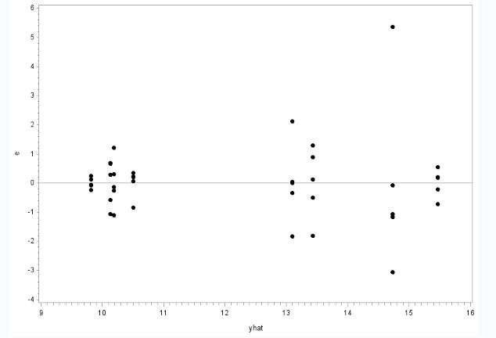

Figure 2: residuals vs estimated compression strength

Even assuming that we the outlier point is a typo and we can exclude it from our model, still we see funnel shape in the model suggesting nonconstancy of variance for residuals.

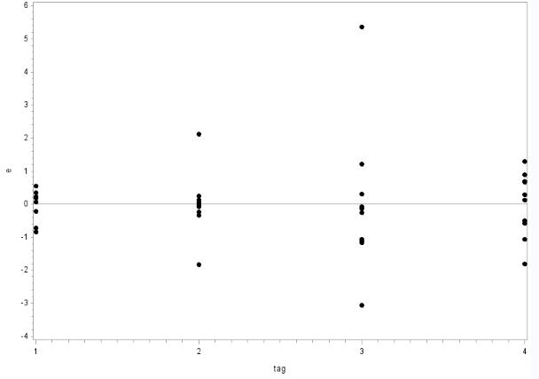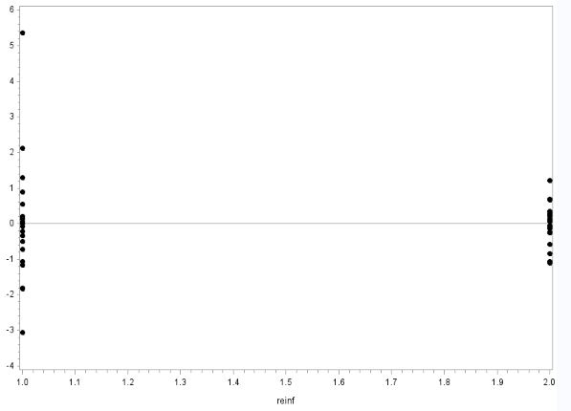

Figure 3: Residuals vs. Tag

Figure 4: residual Vs. Reinforcement

Also by looking at Residuals vs. reinforcement with two levels and residuals vs. tag with 4 levels, we can see that variability of residuals is not constant among different factors (the same assumption for not considering outlier is also considered here.)

For supporting our conclusion we conduct a modified-levene test for constant variance at significance level of $α=0.1$. Modified-Levene test is valid here, although our model is not normal, since the modified-levene is robust against non-normality, we can use it. We split our data to two groups for trt combination $≤4$ and trt combination $>$ 4.

*Test*:

Ho: Variance is constant

H1: Variance is not constant

*Decision Rule:*

If p-value is less than $α=0.1$ level then reject the null hypothesis.

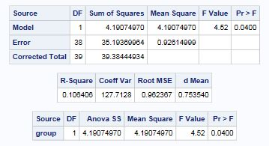

Table2: Modified-levene SAS output

Since p-value 0.0400 < $α=0.1$, then we reject Ho and support what we saw earlier on the relevant plot which is violation from constancy of variance for residuals.

**Normality of random errors term**

On the stated model above, we assume that random errors are normality distributed. We check this assumption by create Normal probability plot with scaled residuals on y axis and normal scores on x axis. Here we are looking for relatively high correlation between residuals and normal scores which can be interpret as a relatively straight line in NPP plot and also can be supported (or not) by the NPP test.

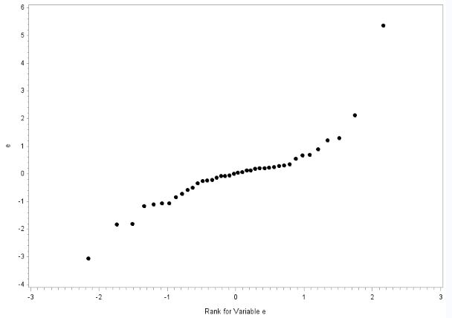

Figure 5: NPP plot for residuals

NPP plot shows longer tails at both left and right (even we exclude orange circled from our NPP analysis) which means Normality of residuals are violated.

We conduct a NPP test as below:

$$H_{0}: Normality is OK$$

$$H_{1}: Normality is Violated$$

| **Pearson Correlation Coefficients, N = 40 Prob > |r| under H0: Rho=0** | | |
| --- | --- | --- |
|  | **e** | **enrm** |
| **e** | 1.00000 | 0.89862  <.0001 |

Table1: NPP SAS output

Decision Rule: if $\hat{ρ } < c\left(α,n\right) then reject H_{0}$

$enrm= \hat{ρ}$**= 0.89862 $< c\left(0.1,40\right)=0.977$**  Reject ${ H}_{0}$, Normality is violated

Conclusion: What I have seen on plot is consistent with what we conclude from the NPP test. Normality is violated.

Since our constant variance and normality are both violated, we do not check other model assumption such as outliers and serial correlation since these two critical model assumption should first modified by necessary transformation and then we recheck all model assumption again.

**Necessary Transformation**

Since our model is violated both in normality and constant variance, we can try a variance-stabilizing transformation on the compression strength (response). Since Box Cox did not work on our SAS edition, we checked transformation with different value of λ and the best one is transformation with (λ=0) which mean log transformation on response (compression strength).

**Transformed Model**

Cell means Model (Fixed Effects):

Full Interaction Model:

$log⁡(Y_{ijt}){=μ_{ij}+ε_{ijt} μ}_{ij}= μ_{..}+τ_{ij}= μ_{..}+ α_{i}+ β_{j}+({αβ)}_{ij}$, $ε_{ijt}\sim N(0,σ^{2})$

$Y_{ijt}= t^{th} observed value of compression strength in psi at i^{th} level of tag and j^{th} level of reinforcement$

$µ_{..}$ = Overall mean of the the compression strength

$α_{i}$**:** Main Tag modification effects with 4 levels = no tag included (control), 2 = complete tag, 3 = cut away tag, 4 = abraded tag

**:** Main Reinforcement effects with 2 levels = Kevlar, = Glass

Balanced:

**=** interaction effects of tag at level i and reinforcement at level j (

**r** = replications of each treatment combination (# trt combination = 8), r = 5 (balanced experiment)

= Independent random error with N (0, σ2)

**Recheck Model Assumption**

1. **constant Variance**

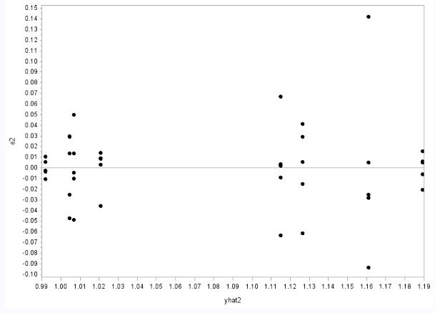

We tried many transformation among which log transformation was seemingly best of worst meaning that we may still have a slightly funnel shape, but if we assume that extreme points are negligible then the funnel is now modified to some extent. We also check constant variance with modified-leven test. For this prupose, we split our data to two groups for trt combination $≤4$ and trt combination $>$ 4. (two groups each with for trt combination)

Table 3: residuals vs. estimated log compression strength

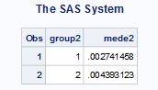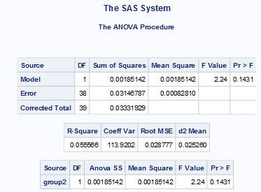

*Test*:

Ho: Variance is constant

H1: Variance is not constant

*Decision Rule:*

If p-value is less than $α=0.1$ level then reject the null hypothesis.

Since p-value 0.1431 $> α=0.1$, then fail to reject Ho and support our earlier comment on the figure.6 which was the reasonable constancy of variance in residuals after applying the log transformation.

1. **Normality of residuals**

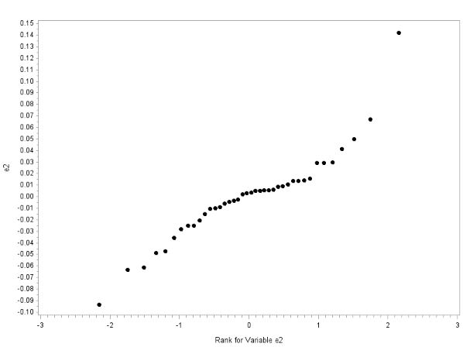

Figure 8: NPP plot **before** transformation

Figure 7: NPP plot **after** transformation

The normal probability plot log transformed model seems much straighter than original model. We can check the correlation of residuals by the normality test.

$$H_{0}: Normality is OK$$

$$H_{1}: Normality is Violated$$

Decision Rule: if $\hat{ρ } < c\left(α,n\right) then reject H_{0}$

$enrm= \hat{ρ}$**= 0.94447 $< c\left(0.1,40\right)=0.977$**  Reject, Normality is violated by the test

But if we compare correlation after transformation with the original model, we have

${\hat{ρ}}_{new}$**= 0.94447 > ${\hat{ρ}}_{original}=$ 0.89862,** we see a higher correlation after transformation. We rely on what we saw on the plot and assume normality is reasonable.

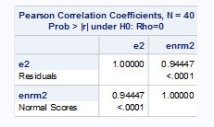

After satisfying model assumption with highest priority, we can now go further and check other assumption such as serial correlation and outliers test.

1. **Serial Correlation**

The compression data collection is not dependent on time meaning there is no need to check residuals vs. observation order.

1. **Outlier test**

As we showed before on the figure 6, definitely there is an outlier far apart from other observations that has been detected on other plots as well. Here we are using bonferroni outlier test to detect outliers. This potential outlier might be one of the reasons that disrupt the assumption of normality and constant variance for the error term.

*Bonferroni outlier Test:*

H0: There is No outlier.

H1: There is at least one outlier.

*Decision Rule:*

Reject H0 if .

From SAS output, table below is the values for studentized deleted residuals.

For observation 15,

$\left|t_{it}\right|=4.86149 > t_{31, 0.00125}=3.29$ Detected as an outlier.

This observation is the same extreme point that we marked everywhere on the plot that comes from treatment combination Kevlar (A1) and cut away tag (B3). Even by looking at the residuals vs. treatment combination we see that this combination has the largest variability of residuals. By asking the experimenter (Billy), he left a comment as following. During compression test the parts are supposed to compress which leaves a fracture point through the thickness of the part. The outlier failed through the length of the part instead. This means that the experimenter either cut the part in the wrong direction for the single part when he was cutting out test specimens (fairly likely) or he messed up fabrication of the other four parts (highly doubtful). Since, we are not definitely sure about these possible reasons, and did not have enough time to conduct an experiment again to make sure if this variability only comes from the outlier or it is related to the treatment combination for Kevlar (A1) and cut away tag (B3), we do our further analysis without considering the outlier as a typo. Therefore, in the next experiment we should collect data more carefully or we may find some other source of variability or nuisance factor that might be helpful.

At this point, after validating model assumption, we can go further in our analysis on analysis of variance.

| **Obs** | **tres2** | **obs** | **tres2** |
| --- | --- | --- | --- |
| **1** | -0.53400 | **21** | -0.93273 |
| **2** | -0.15168 | **22** | 0.08339 |
| **3** | 0.15251 | **23** | 0.24137 |
| **4** | 0.13248 | **24** | 0.37073 |
| **5** | 0.39932 | **25** | 0.22566 |
| **6** | -1.71007 | **26** | -0.08682 |
| **7** | -0.23675 | **27** | -0.06499 |
| **8** | 0.05019 | **28** | -0.26916 |
| **9** | 0.09117 | **29** | 0.27786 |
| **10** | 1.81997 | **30** | 0.14317 |
| **11** | -2.67874 | **31** | -0.11045 |
| **12** | -0.65143 | **32** | -0.26314 |
| **13** | -0.73469 | **33** | -1.29426 |
| **14** | 0.12732 | **34** | 1.31631 |
| **15** | 4.86149 | **35** | 0.35364 |
| **16** | -1.65370 | **36** | -1.25514 |
| **17** | 0.14314 | **37** | -0.64698 |
| **18** | -0.38809 | **38** | 0.34705 |
| **19** | 0.76489 | **39** | 0.77553 |
| **20** | 1.09195 | **40** | 0.75956 |

**III. Analysis of Variance**

On this part we statistically check our significance of the full model given on transformed model. And if any of effects turn out to be not statistically significant we consider the new model for future work.

**Interaction plot**

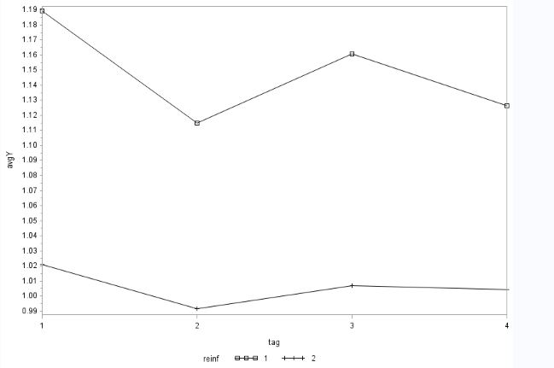

Figure 6: Interaction plot

First, before conducting proper F-test, by looking at interaction plot, we can interpret it to see if we can see if there is any interaction effects between tag and reinforcement levels.

Based on the figure 7, as we see all piece of lines does have the same pattern, but are not parallel, suggesting that there might be some slight form of interaction effects. This means that the average change in compression strength (psi) in different level of tag is dependent upon on different level of reinforcement (glass or Kevlar). The significance of our interpretation must be checked by two way ANOVA test and checking the proper P-value.

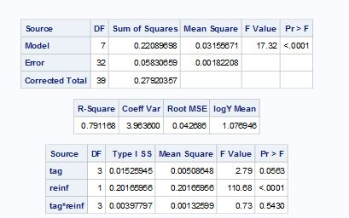

**2.1**

**2.2**

**1**

The F-test should be done in proper order. For this purpose, we start with testing the interaction effects.

1. **Tag reinforcement Interaction effect test**

$H_{0}^{AB}$: AB interaction is negligible.

$H_{1}^{AB}$: AB interaction is not negligible.

*Decision Rule:*

Reject $H_{0}^{AB}$ if p-value is less than significance level.

Table 4: Two Way ANOVA - Full Interaction Model

With significance level $α=0.1$, the p-value of 0.5430 (shown by #1 on table 4) is greater than 0.1, we fail to reject null hypothesis concluding that the interaction effect between factors, reinforcement and tag, is negligible. This means that the correct model for future work is additive model without any interaction term. Also at the next step, since we conclude that the interaction effect are not significant, then we should test the significance of main effects for reinforcement and tag. And conduct multiple separate comparison on significant reinforcement and tag levels.

**2.1) Tag effect:**

$H_{0}^{A}$: Main effect for tag is negligible.

$H_{1}^{A}$: Main effect for tag is not negligible.

***Decision Rule:***

Reject $H_{0}^{A}$ if p-value is less than significance level.

With significance level $α=0.1$, since the p-value of 0.0563 (shown by #2.1 on table 4)is less than 0.1, we reject null hypothesis means that tag main effect is significant and we should keep it for correct future model.

**2.2) Reinforcement effect:**

$H_{0}^{B}$: Main effect for reinforcement is negligible.

$H_{1}^{B}$: Main effect for reinforcement is not negligible.

***Decision Rule:***

Reject $H_{0}^{B}$ if p-value is less than significance level.

With significance level $α=0.1$, the p-value of <0.0001 (shown by #2.2 on table 4) is less than 0.1, we reject null hypothesis means that reinforcement main effect is significant and we should keep it for correct future model.

So the correct future model would be presented below:

$$log⁡(Y_{ijt}){=μ_{ij}+ε_{ijt} μ}_{ij}= μ_{..}+τ_{ij}= μ_{..}+ α_{i}+ β_{j}$$

**Normal probability plots for effects**

By assuming normality (that we verified the normality assumption on model assumption part after transformation), if the treatment means are equal, it means they come from a same normal population with the overall mean of compression strength. Here, the straight line stands for that expected value of overall mean of population.

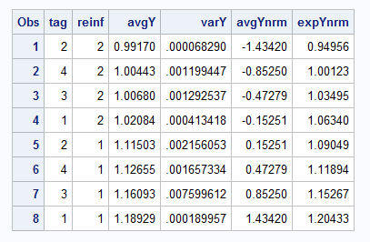

Therefore, if the points (which stands for normal scores for treatment means) are close to the reference line (stands for expected value of the overall mean of the normal population), then we can interpret it as treatment means are not different. Here, although the higher four points are close to the reference line but altogether points are not close to the line, supporting that treatment means are different.

Table 5: Normal scores for treatment mean

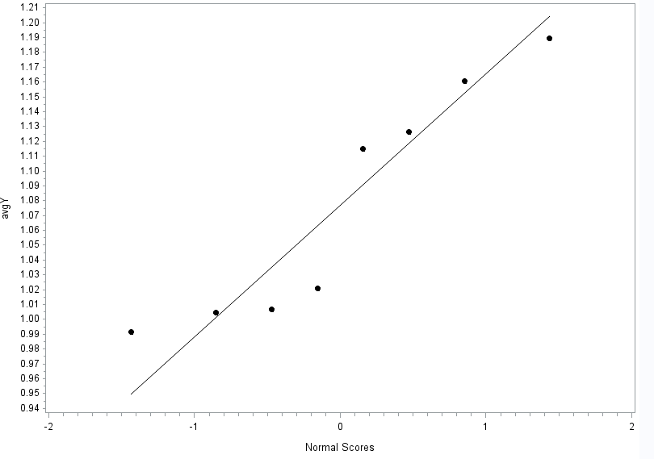

Figure 7: NPP for treatment means

**All Effect estimation**

These estimation is derived by least square estimation on SAS output minus logY mean for the main effects and the interaction effects are derived by LSmeans for tag*reinf – LSmeans for tag – Lsmeans for reinf + logY mean. we just make a comment on table to be detectable.(the LS means tables from SAS output are provided in appendix on page 22)

| **tag** | **logY main effect** | **Main Effects for levels of tag** |
| --- | --- | --- |
| **1** | 0.02812118 | $$α_{1}=main effect for no tag$$ |
| **2** | -0.02358122 | $$α_{2}=main effect for complete tag$$ |
| **3** | 0.00691657 | $$α_{3}=main effect for cut away tag$$ |
| **4** | -0.01145562 | $$α_{4}=main effect for abraded tag$$ |

Table 6: Main Effects for levels of tag

| **reinf** | **logY main effect** | **Main effects for level of reinforcement** |
| --- | --- | --- |
|  |
| **1** | 0.07100367 | $$β_{1}=main effect for Kevlar$$ |
| **2** | -0.07100322 | $$β_{2}=main effect for glass$$ |

Table 7: Main Effects for levels of reinforcement

| **tag** | **reinf** | **logY main effect** | **Interaction Main effects** |
| --- | --- | --- | --- |
| **1** | **1** | 0.01322293 | $${αβ}_{11}$$ |
| **1** | **2** | -0.01322339 | $${αβ}_{12}$$ |
| **2** | **1** | -0.00934234 | $${αβ}_{21}$$ |
| **2** | **2** | 0.00934189 | $${αβ}_{22}$$ |
| **3** | **1** | 0.00606360 | $${αβ}_{31}$$ |
| **3** | **2** | -0.00606404 | $${αβ}_{32}$$ |
| **4** | **1** | -0.00994509 | $${αβ}_{41}$$ |
| **4** | **2** | 0.00994464 | $${αβ}_{42}$$ |

Table 8: Main Effects for interaction main effects

**IV. Analysis of Eﬀects**

Since the interaction was negligible based on last part, and also the main effects for tag and reinforcement was significant at $α=0.1$, then the comparisons are conducted on the 4 levels of tag and 2 levels of reinforcement separately.

By Tukey pairwise comparisons, we have confidence intervals for each difference between factor effects. If any of those confidence intervals include 0, then we fail to reject null hypothesis for the tests below. Therefore, we note again since the interactions are not significant then we conduct Tukey comparisons and also line plots only for 4 level of tag and 2 level of reinforcement separately.

1. **Tukey pairwise comparisons for 4 level of Tag ($α=0.01)$**

*Test:*

$H_{0}: μ_{i.}-μ_{j.}=0 ∀i≠j$

$H_{1}: μ_{i.}-μ_{j.} ≠0 ∀i≠j$

***Decision Rule:***

If the confidence interval includes zero, we will fail to reject H0.

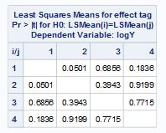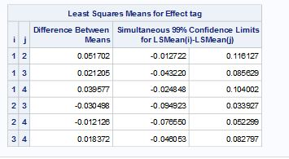

Table 10: p-value for tag mean

Table9: Tukey confidence interval for tag means

Firstly, we are 99% confident that the true mean difference of compression strength between relevant different tag levels are somewhere between the relevant intervals (in psi) marked with a red rectangle above. Secondly, As we see from Simultaneous confidence interval $∀ij i≠j$, $0∈CI$. Equivalently, the p-value for the above Tukey test is all greater than 0.01, meaning that 4 levels of tag means are indistinguishable. The equivalent line plot is shown below.

| **tag** | **logY LSMEAN** | **Sorted tag treatment** |
| --- | --- | --- |
| **1** | 1.10506718 | 4 |
| **2** | 1.05336478 | 1 |
| **3** | 1.08386257 | 3 |
| **4** | 1.06549038 | 2 |

*Table9: sorted Least square estimates for tag level means*

(2) Complete tag (4) abraded tag (3) cut away tag (4) no tag

*Figure 8: Line plot for Tag means*

1. **Tukey pairwise comparisons for 2 level of Reinforcement ($α=0.01)$**

*Test:*

$H_{0}: μ_{.i}-μ_{.j}=0 ∀i≠j$

$H_{1}: μ_{.i}-μ_{.j} ≠0 ∃i≠j$

***Decision Rule:***

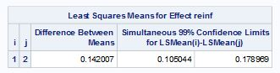If the confidence interval includes zero, we will fail to reject H0.

Table 10: Tukey confidence interval for reinforcement means

Firstly, we are 99% confident that the true mean difference of compression strength between glass and Kevlar is somewhere between 0.105044 psi and 0.178989 psi. Secondly, As we see from Simultaneous confidence interval $0 is not in CI$, meaning that 2 levels of reinforcement are distinguishable. The equivalent line plot is shown below.

| **reinf** | **logY LSMEAN** | **Sorted reinf treatment** |
| --- | --- | --- |
|  |
| **1** | 1.14794967 | **2** |
| **2** | 1.00594278 | **1** |

*Table 11: sorted least square estimates for reinforcement level means*

(2) Glass (1) Kevlar

*Figure 9: Line plot for reinforcement means*

**Multiple Comparisons (Family confidence level of $99\%$)**

In this experiment, we have 4 pre-selected contrast that we are interested to know about. All these four contrasts are useful for the goal of the experiment that was stated earlier in proposal. By considering main effects for multiple comparsions, we used Bonferroni method for these 4 contrasts.

1. Glass versus Kevlar $L_{1}=μ_{.1}- μ_{.2}$
2. No Tag versus Tag ${L_{2}= μ}_{1.}- \frac{μ_{2.}+μ_{3. }+μ_{4.}}{3}$
3. Complete tag versus Abraded tag ${ L_{3}= μ}_{2.}-μ_{3.}$
4. Complete tag versus Cut away tag ${ L_{4}= μ}_{2.}-μ_{4.}$

***Test:***

$H_{0}: L_{i}=0 ∀i (1,… ,4)$

$H_{1}: L_{i}≠0 ∃i$

***Decision Rule:***

If the confidence interval includes zero, we will fail to reject H0.

With a family confidence level of at least 99%, the Bonferroni CI is: $\hat{L} ±w_{B}Se(\hat{L})$

$w_{B}= t-value= t_{30-8 , {0.01}/{2*4} }=t_{22, 0.00125}=3.412$

| **contrast** | **Parameter** | **Estimate ($\hat{L})$** | **Standard Error**  **Se($\hat{L})$** | **t Value** | **Pr > |t|** | **Comparison with α = 0.01** | **Conclusion**  **at α = 0.01** |
| --- | --- | --- | --- | --- | --- | --- | --- |
| $$L_{1}$$ | **Kevlar vs Glass** | 0.14200689 | 0.01349845 | 10.52 | <.0001 | < **α = 0.01 Reject H0** |  |
|  | **No Tag vs Tagged** | 0.11248380 | 0.04675999 | 2.41 | 0.0221 | > **α = 0.01 FTR H0** |  |
|  | **Complete Tag vs Abraded** | -0.01212560 | 0.01908969 | -0.64 | 0.5298 | > **α = 0.01 FTR H0** |  |
|  | **Complete Tag vs Cut away** | -0.03049779 | 0.01908969 | -1.60 | 0.1200 | > **α = 0.01 FTR H0** |  |

*Table 12: Bonferroni result*

$L_{1} ∈0.14200689±3.412*0.01349845= \left(0.0960, 0.1881\right) does not include 0$

$L_{2} ∈0.11248380±3.412*0.04675999= \left(-0.0471, 0.2720\right) include 0$

$L_{3} ∈-0.01212560±3.412*0.01908969= \left(-0.0773, 0.0530\right) include 0$

$$L_{4} -0.03049779±3.412*0.01908969= \left(-0.0956,0.0346\right) include 0$$

Firstly, with family confidence level of at least 99%, true mean difference of compression strength between Kevlar and glass, true mean difference of compression strength between No tag and tagged, true mean difference of compression strength between complete tag and abraded tag, and true mean difference of compression strength between complete tag and cut away tag are simultaneously somewhere between the corresponding CI (in psi).

In other word, we are 90% confident that true compression strength mean for Kevlar is greater than glass, while the true mean compression strength for other three contrast are not different from each other, at the same time.

Finally, if we change our approach from conservative (α = 0.01) to the significance level of (α = 0. 1), the conclusion would be different. This is important since the contrast of Tag versus no tag is a key contrast in our study. Therefore, at α = 0. 1, the mean compression strength would be greater than tagged. This conclusion is only true by simultaneously taking into account other three contrast conclusion at new significance level (α = 0. 1). The discussion on what significance level is more appropriate is completely dependent on this specific experiment and out of the scope of this project.

**V. Final Discussion**

Summary: an experiment was conducted to measure the compressive strength of the composite materials. The composite materials selected for the test were Kevlar and glass composites. The hypothesis to test was whether the inclusion of RFID tags in the test specimens does not significantly affect the mechanical properties of the material. However it is expected that the two composite materials will yield different magnitudes of compressive strength. The factors involved in the analysis were 4 types of tag modifications for every composite material. Also 5 samples of each material type for each tag modifications were tested. The report analyses these results. From the preliminary analysis of the model, it was concluded that the constant variance assumption is violated. It was seen from the normal probability plot that the normality was a borderline case and could be concluded that the normality assumption is satisfied. In order to satisfy the constant variance assumption a log transformation was used and the results are shown in the report. Although there the variance has some departures, it was mainly due to the presence of an outlier which in turn was due to abnormality while cutting the test specimen. The transformation yielded a better result for satisfying constant variance and normality assumptions and hence was included in the model. After finalizing the transformation, the analysis of variance was tested to calculate the estimates and check for the significance of interaction and main effects. A normal probability plot for effects was plotted to check similarity between treatment means. Finally a pairwise Tukey comparison and multiple comparison using Bonferroni was carried out.

Conclusion: It can be concluded from the analysis of the experiment that the transformations are necessary to stabilize the variance. The log transformation yields the best results however the presence of outlier causes certain variability in the transformed model. As a part of future work, the test specimen can be re-run for checking compressive test with proper cut away of the material. We are hopeful that this might eliminate the outlier. The normality assumption was satisfied in the transformed model with a better NPP plot as compared to the initial model. To conduct the ANOVA tests, full model with interaction terms was used. However after performing F-tests to check the significance of interaction terms and main effects, it was concluded that the significance of interaction terms between the two factors was negligible and can be eliminated from the future model. Thus the model for future use would be an additive model containing both the main effects. For future work, the model could be implemented on different type of experiment to test different mechanical properties such as tensile strength and shear strength. There is also a possibility of adding another factor for future experiment. This factor is the RF strength for the tag with two levels, namely, >50ft and <50ft. the goal would be to see if the material type or process impacts the signal strength. This will be a factor and not a block.

**Appendix**

|  |  |  |  |  |  |
| --- | --- | --- | --- | --- | --- |
| Before Randomization | | |  | After Randomization | |
| 90522 | | K1 |  | 01324 | K3 |
| 62084 | | K1 |  | 10816 | G1 |
| 90591 | | K1 |  | 15943 | K3 |
| 96213 | | K1 |  | 23361 | K4 |
| 49577 | | K1 |  | 24099 | K4 |
| 71793 | | K2 |  | 25857 | K2 |
| 38508 | | K2 |  | 26966 | G4 |
| 25857 | | K2 |  | 37798 | K3 |
| 96351 | | K2 |  | 38508 | K2 |
| 91116 | | K2 |  | 44085 | K4 |
| 37798 | | K3 |  | 44317 | K3 |
| 15943 | | K3 |  | 48845 | G4 |
| 01324 | | K3 |  | 49577 | K1 |
| 57864 | | K3 |  | 49769 | G2 |
| 44317 | | K3 |  | 51365 | G3 |
| 24099 | | K4 |  | 51883 | G2 |
| 44085 | | K4 |  | 51894 | G1 |
| 56697 | | K4 |  | 53547 | G4 |
| 23361 | | K4 |  | 55266 | G2 |
| 63605 | | K4 |  | 56682 | G3 |
| 10816 | | G1 |  | 56697 | K4 |
| 51894 | | G1 |  | 57864 | K3 |
| 75295 | | G1 |  | 58113 | G1 |
| 58113 | | G1 |  | 62084 | K1 |
| 92744 | | G1 |  | 63230 | G2 |
| 55266 | | G2 |  | 63605 | K4 |
| 63230 | | G2 |  | 65426 | G2 |
| 49769 | | G2 |  | 68437 | G3 |
| 51883 | | G2 |  | 70462 | G3 |
| 65426 | | G2 |  | 71793 | K2 |
| 99393 | | G3 |  | 75295 | G1 |
| 68437 | | G3 |  | 77561 | G4 |
| 70462 | | G3 |  | 83765 | G4 |
| 51365 | | G3 |  | 90522 | K1 |
| 56682 | | G3 |  | 90591 | K1 |
| 26966 | | G4 |  | 91116 | K2 |
| 83765 | | G4 |  | 92744 | G1 |
| 53547 | | G4 |  | 96213 | K1 |
| 77561 | | G4 |  | 96351 | K2 |
| 48845 | | G4 |  | 99393 | G3 |
| Compression Test Experiment | | | | |

| **Obs** | **strength** | **tag** | **reinf** | **tc** |
| --- | --- | --- | --- | --- |
| **1** | 14.746 | 1 | 1 | 1 |
| **2** | 15.255 | 1 | 1 | 1 |
| **3** | 15.675 | 1 | 1 | 1 |
| **4** | 15.647 | 1 | 1 | 1 |
| **5** | 16.023 | 1 | 1 | 1 |
| **6** | 11.262 | 2 | 1 | 2 |
| **7** | 12.760 | 2 | 1 | 2 |
| **8** | 13.091 | 2 | 1 | 2 |
| **9** | 13.139 | 2 | 1 | 2 |
| **10** | 15.210 | 2 | 1 | 2 |
| **11** | 11.676 | 3 | 1 | 3 |
| **12** | 13.672 | 3 | 1 | 3 |
| **13** | 13.573 | 3 | 1 | 3 |
| **14** | 14.651 | 3 | 1 | 3 |
| **15** | 20.090 | 3 | 1 | 3 |
| **16** | 11.616 | 4 | 1 | 4 |
| **17** | 13.555 | 4 | 1 | 4 |
| **18** | 12.928 | 4 | 1 | 4 |
| **19** | 14.320 | 4 | 1 | 4 |
| **20** | 14.727 | 4 | 1 | 4 |
| **21** | 9.664 | 1 | 2 | 5 |
| **22** | 10.570 | 1 | 2 | 5 |
| **23** | 10.720 | 1 | 2 | 5 |
| **24** | 10.844 | 1 | 2 | 5 |
| **25** | 10.705 | 1 | 2 | 5 |
| **26** | 9.735 | 2 | 2 | 6 |
| **27** | 9.754 | 2 | 2 | 6 |
| **28** | 9.578 | 2 | 2 | 6 |
| **29** | 10.057 | 2 | 2 | 6 |
| **30** | 9.937 | 2 | 2 | 6 |
| **31** | 10.058 | 3 | 2 | 7 |
| **32** | 9.922 | 3 | 2 | 7 |
| **33** | 9.076 | 3 | 2 | 7 |
| **34** | 11.389 | 3 | 2 | 7 |
| **35** | 10.483 | 3 | 2 | 7 |
| **36** | 9.056 | 4 | 2 | 8 |
| **37** | 9.539 | 4 | 2 | 8 |
| **38** | 10.420 | 4 | 2 | 8 |
| **39** | 10.820 | 4 | 2 | 8 |
| **40** | 10.805 | 4 | 2 | 8 |

**Least Square means for tag, reinforcement and tag*reinforcement**

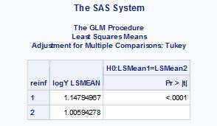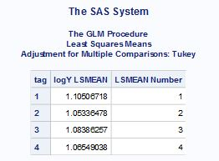

**Reinforcement**

**Tag**

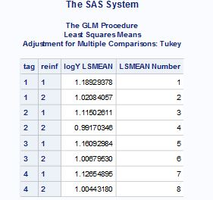

**Tag*reinf**